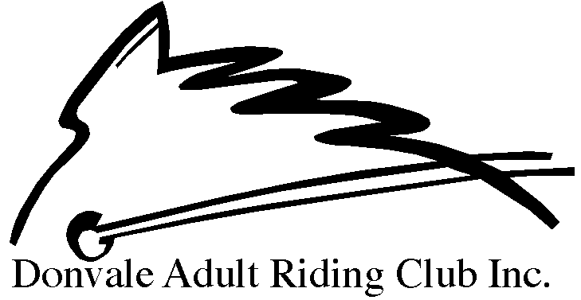
MEMBERSHIP APPLICATION FORM
1 November 2019 – 31 October 2020
Membership Type: | HRCAV Membership Number
_{Renewal} _{New HRCAV Member}
HRCAV Member of another club? | If yes, name of Club: | Has HRVAC insurance been paid with your other club?
Yes No |  | Yes No
Personal Details:
Name |  | DOB
Mailing Address |  | P/code
Home Phone |  | Mob
Email Address
Fees:
*(Please select one HRCAV membership option only)
DARC Membership Fee | Annual Fee | $120.00 | $120
HRCAV Levy and Insurance (Senior)* | Annual Fee | $155.00
HRCAV Levy and Insurance (Non-Riding Member)* | Annual Fee | $30.00
Chaff Chat Online (optional) | Annual Fee | $30.00
Chaff Chat Printed (optional) | Annual Fee | $70.00
Total Fees Payable |  |  | $

Payment Details:
Payment will only be accepted by direct deposit.
- by Direct Transfer –Donvale Adult Riding Club – BSB: 033 389 – Account #: 187 619
Receipt No: ………………………………………………………………………………….
Ensure that your name is in the transfer details.

Declarations & Privacy:
I hereby apply for membership to the DONVALE ADULT RIDING CLUB and I agree to abide by the club’s rules and regulations and that of the HRCAV.
I acknowledge and agree to:
- Wear an approved helmet when mounted and appropriate footwear at all times
- Recognise that DARC is dependent upon its members and will assist in a voluntary capacity at working bees, official events and committee meetings as required
- Assist in rally duties or dragging arenas according to the club roster, details of which will be published with rally and clinic times
- Accept that horse riding is a hazardous and dangerous sport, and I indemnify DARC against any claim for injury I may suffer while I am engaging in this sport or any club activities
- All rally, completion, clinic, fundraising fees etc to be paid upon booking of said activity
I provide permission for:
- The HRCAV to provide my personal details to any HRCAV sponsor? Yes No
- My name and phone number to be available to other club members and officials? Yes No
- Photo/s of either my horse or myself being published on the club’s website or newsletter? Yes No

Requirements for membership
It is a requirement that all members of the club provide assistance to the club in the following ways throughout the year:
- Assist at club competitions for a minimum of 3 hours
- Perform rally duties throughout the year as specified by roster or grading of the arena
- Attend one working bee and one committee meeting per financial year (Committee meeting roster will be email to all members. If you are unable to attend, you will need to organise a swap with another club member to ensure a quorum can be met at each meeting)

Emergency contact information
- Name: Number:
- Name: Number:

Signature of Member ………………………………………………………… Date ……………………………………………….

Notes:
- All members who are re-joining HRCAV must provide a membership number. Memberships will not be processed without this information.
- This form must be accompanied by the HRCAV disclaimer. Without this, memberships will not be processed.
- All forms to be email to donvalesec@hotmail.com
- Members who fail to provide assistance to the club throughout the HRCAV year may not have membership granted the following year.

